EXP-7

**Create a Multimedia Application that Integrates Images, Sound, and Video in a Simple User Interface**

# Aim:

To develop a simple multimedia application that integrates:

* Images • Audio • Video

into a unified user interface using Python and suitable libraries.

# Procedure:

1. Use a Python GUI framework (e.g., tkinter).
2. Integrate:
   * Image loading and display using PIL (Pillow).
   * Audio playback using pygame or playsound.
   * Video playback using opencv or tkinter with ffpyplayer.
3. Arrange all elements in a basic GUI.
4. Provide buttons to trigger media playback.

# Code:

import tkinter as tk

from PIL import Image, ImageTk from playsound import playsound import cv2

import threading

# --- Function to play audio --- def play_audio():

playsound('sample_audio.mp3') # Replace with your audio file name

# --- Function to play video --- def play_video():

cap = cv2.VideoCapture('sample_video.mp4') # Replace with your video file name while cap.isOpened():

ret, frame = cap.read() if not ret:

break cv2.imshow("Video", frame)

if cv2.waitKey(25) & 0xFF == ord('q'): # Press 'q' to quit break

cap.release() cv2.destroyAllWindows()

# --- Function to load and display image --- def load_image():

img = Image.open('sample_image.jpg') # Replace with your image file name img = img.resize((300, 300))

img_tk = ImageTk.PhotoImage(img) panel.configure(image=img_tk) panel.image = img_tk

# --- GUI Setup ---

window = tk.Tk() window.title("Multimedia App")

panel = tk.Label(window)

panel.pack()

btn_img = tk.Button(window, text="Show Image", command=load_image)

btn_audio = tk.Button(window, text="Play Audio", command=lambda: threading.Thread(target=play_audio).start())

btn_video = tk.Button(window, text="Play Video", command=lambda: threading.Thread(target=play_video).start())

btn_img.pack(pady=5) btn_audio.pack(pady=5) btn_video.pack(pady=5)

window.mainloop()

# Output:

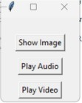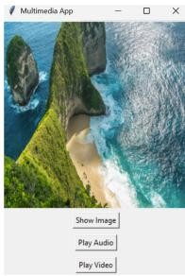

**Result:**

A multimedia application was successfully created that integrates image, audio, and video functionality into a single interactive interface.